Task 1

Run | π obtained | Hits | Runtime
1 | 2.476248 | 30,953,104 | 1274.82 ms
2 | 2.431611 | 30,395,140 | 1308.68 ms
3 | 2.378717 | 29,733,963 | 2705.29 ms
4 | 2.589010 | 32,362,623 | 3352.36 ms
5 | 2.238269 | 27,978,367 | 2801.20 ms
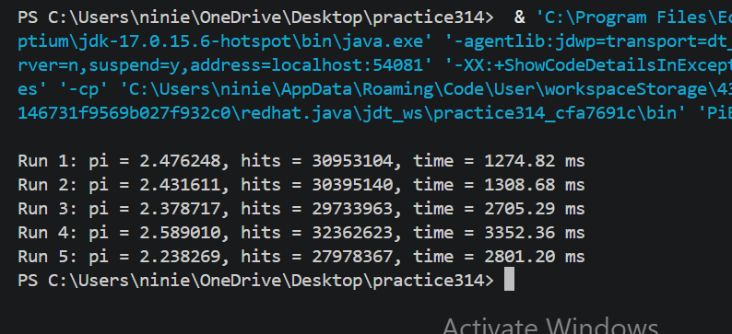

Task2
Version | π | Runtime
Single-threaded | 3.141365 | 2505.29 ms
Synchronized, 4 threads | 3.141768 | 6473.50 ms
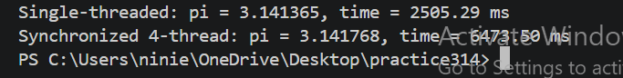

Task 3
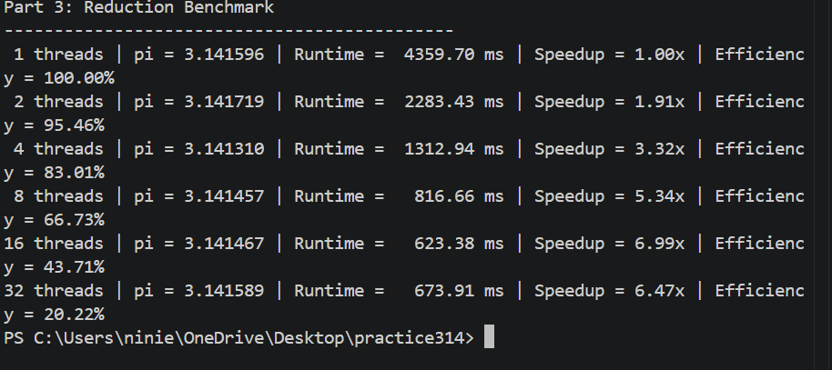
1. Look at your row for 16 threads. Why didn't your 8-core CPU run twice as fast as 8 threads?
An 8-core CPU only has 8 physical cores, so when you throw 16 threads at it, they have to share the same hardware. That’s why you don't get double the performance. In my benchmark, 8 threads took 816.66 ms, and 16 threads took 623.38 ms. It’s faster, but only by about 1.31×. Pushing past the physical core limit brings diminishing returns because the extra threads just end up fighting over resources and adding extra scheduling overhead.
2. Why was the synchronized version in Part 2 slower than running on one single core?
The synchronized version was actually slower because all four threads were fighting over the exact same variable (totalHits). Since synchronization only lets one thread increment the counter at a time, the shared variable turned into a massive bottleneck. Instead of working together, the threads just spent their time waiting in line for the lock.
My benchmark numbers showed this perfectly: a single thread took 2505.29 ms, but the synchronized 4-thread version dragged on for 6473.50 ms—making it 2.58 times slower. It's a great reminder that multithreading doesn’t automatically make things faster; if your threads are constantly blocking each other, the synchronization overhead completely ruins the benefits of parallel execution.

